1. **Files inside this zip file**

* requirements.txt: requirements to install to run the python programs
* tcpserver.py: TCP server file
* udpserver.py: UDP server file
* tcpclient.py: TCP client file to test for multiple clients (optional file)
* udpclient.py: UDP client file to test for multiple clients (optional file)

1. **Test environment**

These programs were tested on two environments. The first was WSL on Windows using Python 3.8.5. The second environment was Ubuntu 20.04 using Python 3.8.5

1. **Installing requirements**

Type the below command in the terminal:

pip3 install -r requirements.txt

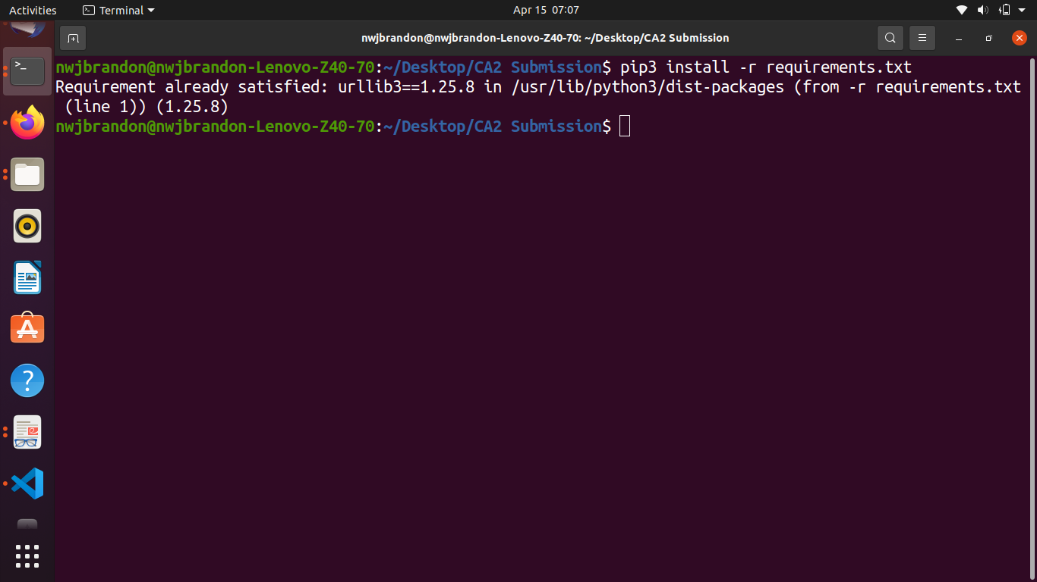

1. **Running TCP server**

To run the TCP server file, type the command in the terminal:

python3 tcpserver.py

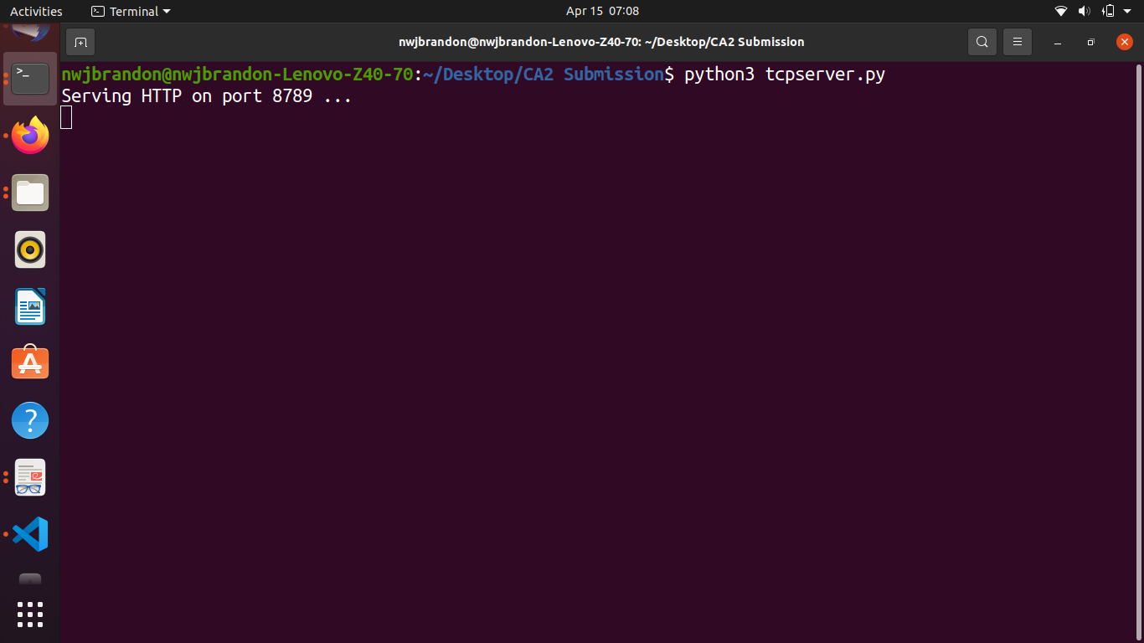

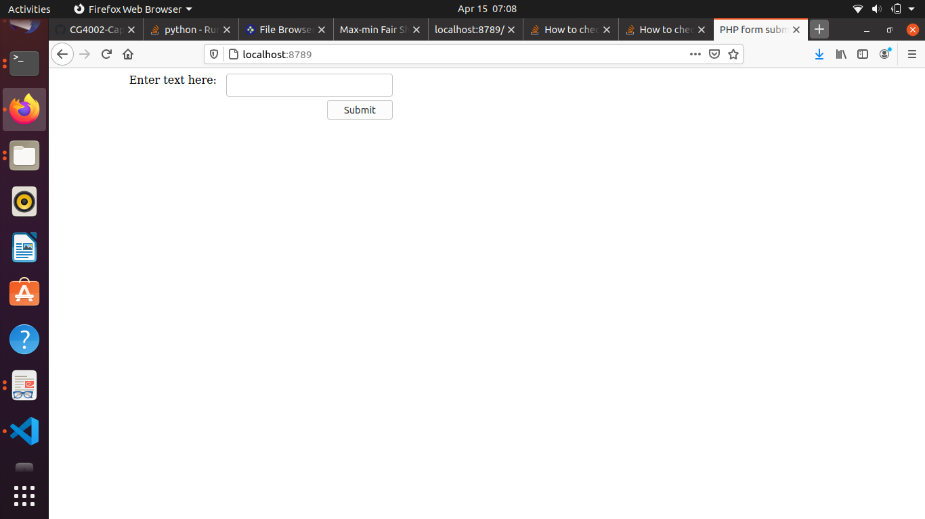

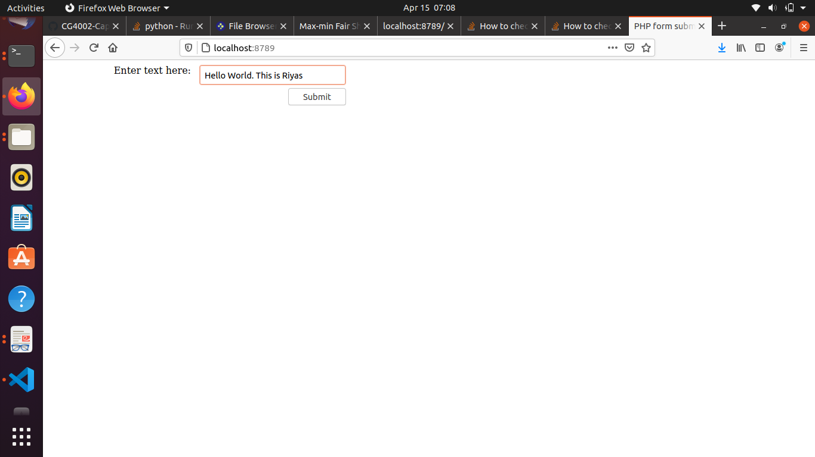

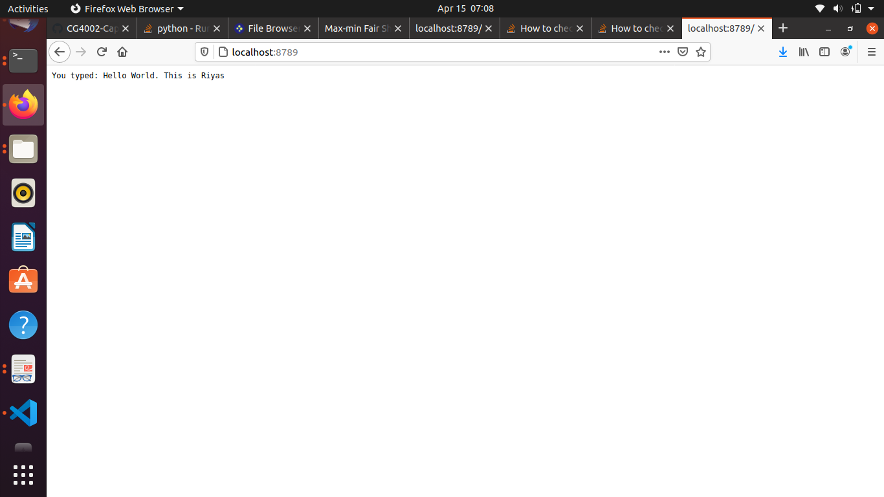

1. **Running UDP server**

To run the UDP server file, type the command in the terminal:

python3 udpserver.py

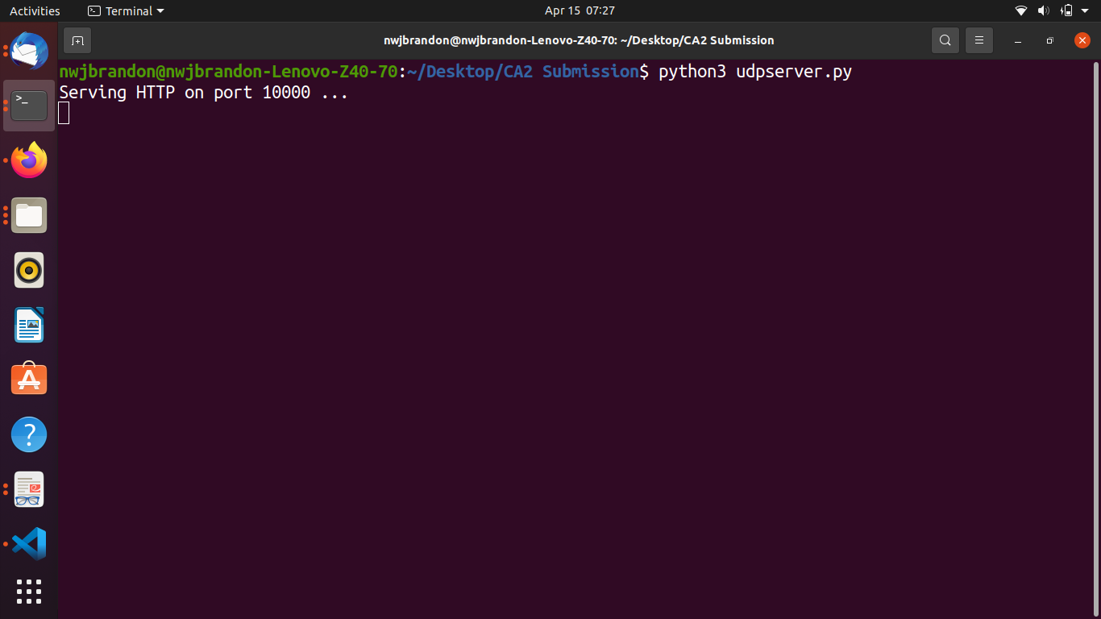

1. **Running TCP client to test multiple clients**

To test multiple clients for the TCP server, run the TCP server file as written above in (4). Then, in a separate terminal type the below command in the terminal:

python3 tcpclient.py --clients [max-clients] --conns [max-connections]

where [max-clients] is a number that reflects maximum number of clients you want to run and [max-connections] is the maximum number of connections per client that you want to run.

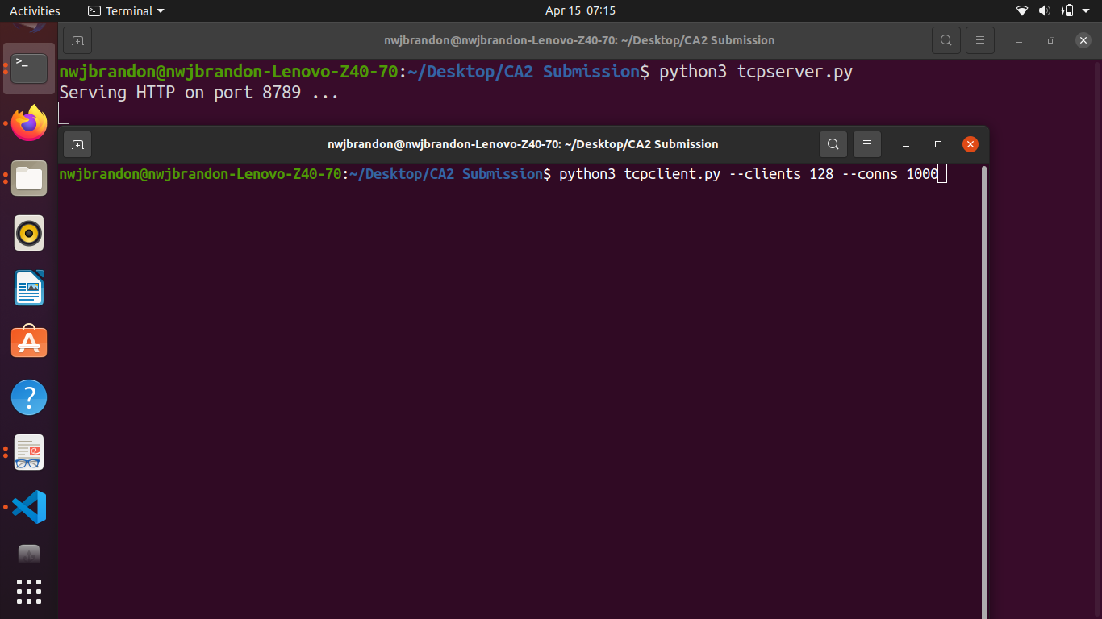

1. **Running UDP client to test multiple clients**

To test multiple clients for the UDP server, run the UDP server file as written above in (5). Then, in a separate terminal type the below command in the terminal:

python3 udpclient.py --clients [max-clients] --conns [max-connections]

where [max-clients] is a number that reflects maximum number of clients you want to run and [max-connections] is the maximum number of connections per client that you want to run.

